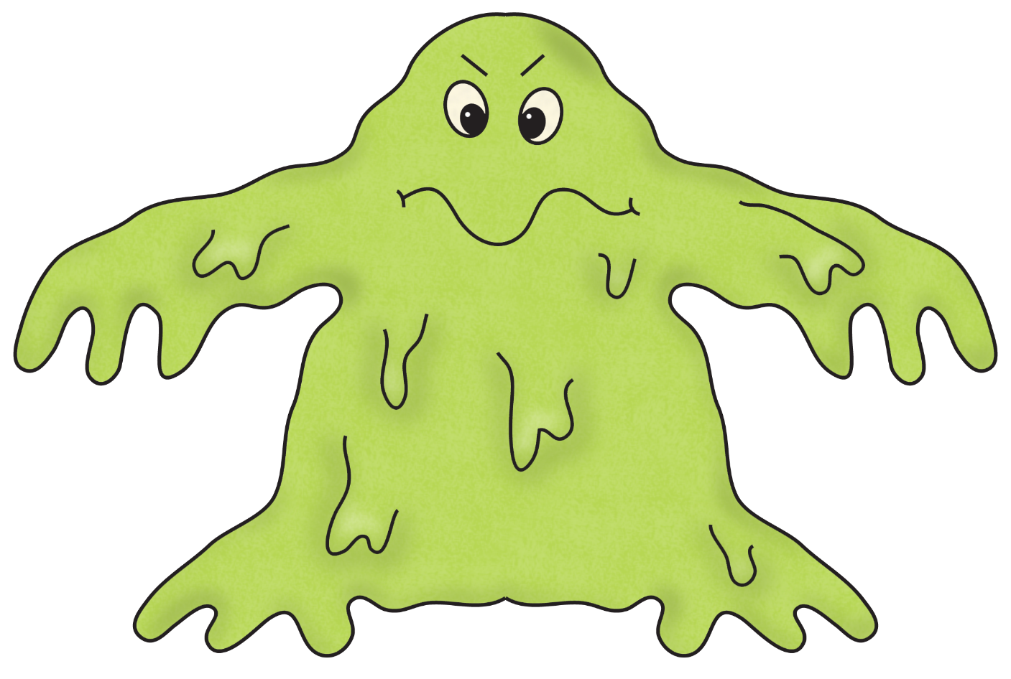

Yuck!

A review game of
VC and CVC words.
By: Brittney Jorgensen

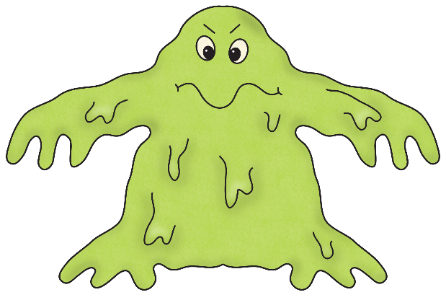  Yuck! | Yuck!
Yuck! | Yuck!
Yuck! | Yuck!
Yuck! | Yuck!
Yuck! | Yuck!
cat | dog
mat | sit
it | is
in | win
rat | bat
cot | hog
hot | not
get | wet
met | let
fat | fit
at | as
his | hop
on | set
sat | hut
dug | bug
mug | lug
shed | led
red | shut
cut | bed
man | pan

